LAPORAN PRAKTIKUM PENGOLAHAN CITRA DIGITAL
17. BASIC MORPHOLOGICAL ALGORITHMS



Disusun oleh :
Nama : Felix
NPM : 2327250059
Kelas : IF41

PROGRAM STUDI INFORMATIKA
FAKULTAS ILMU KOMPUTER DAN REKAYASA
UNIVERSITAS MULTI DATA PALEMBANG
2024

TUTORIAL : BASIC MORPHOLOGICAL ALGORITHMS

Goal
The goal of this tutorial is to learn how to implement basic morphological algorithms
in MATLAB.

Objectives
- Learn how to perform boundary extraction.
- Explore the bwperim function.
- Learn how to fill object holes using the imfill function.
- Explore object selection using the bwselect function.
- Learn how to label objects in a binary image using the bwlabel function.
- Explore the bwmorph function to perform thinning, thickening, and skeletonization.

What You Will Need
- morph.bmp

Procedure
Boundary Extraction
- Load and display the test image.
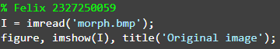
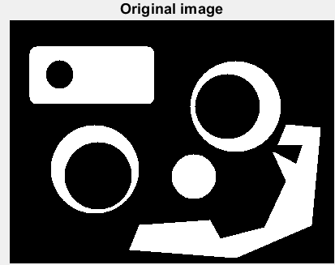

- Subtract the original image from its eroded version to get the boundary image.
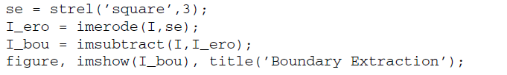
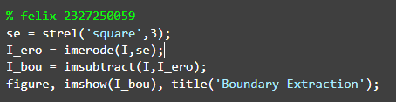
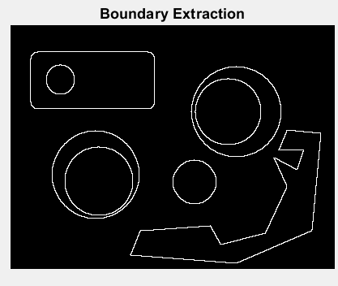

- Perform boundary extraction using the bwperim function.
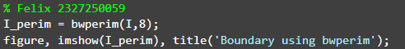
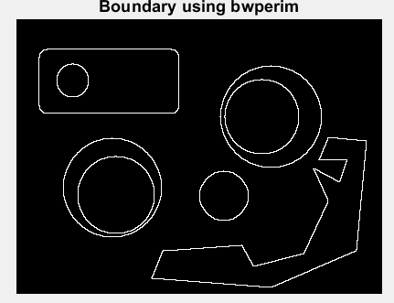

Question 1 Show that the I_perim image is exactly the same as I_bou.
Ya, sama dapat dilihat dari menggunakan fungsi isequa().
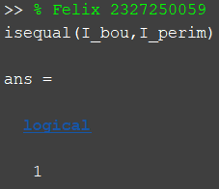

Question 2 If we specify 4-connectivity in the bwperim function call, how will this affect the output image?
Jika menggunakan 4 connerctivity pada bwperim, yang muncul adalah garis tepi pada pola gambar semakin menonjol.

Region Filling
We can use the imfill function to fill holes within objects (among other operations).

- Close any open figures.
- Fill holes in the image using the imfill function.
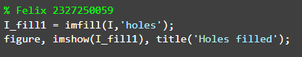
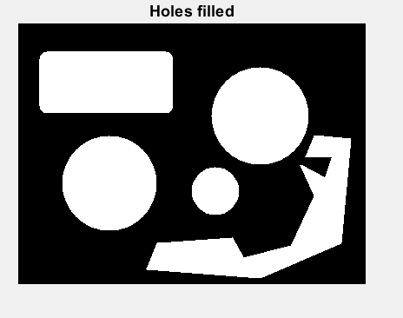

Function imfill can also be used in an interactive mode.

- Pick two of the three holes interactively by executing this statement. After selecting the points, press Enter.
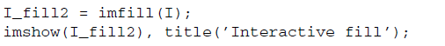

Question 3 What other output parameters can be specified when using imfill?
Tidak banyak, akan tetapi bisa di tambahkan [50 20] dll. Seperti pada potongan berikut.
I_fill2 = imfill(I, [50 20]);

Selecting and Labeling Objects
The bwselect function allows the user to interactively select connected components—which often correspond to objects of interest—in a binary image.

- Close any open figures.
- Select any of the white objects and press Enter.
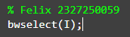

Question 4 In the last step, we did not save the output image into a workspace variable. Does this function allow us to do this? If so, what is the syntax?
Ya bisa, dengan contohnya kode berikut
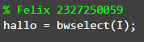

In many cases, we need to label the connected components so that we can reference them individually. We can use the function bwlabel for this purpose.

- Label the objects in an image using bwlabel.
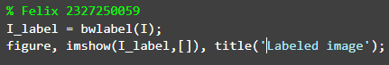
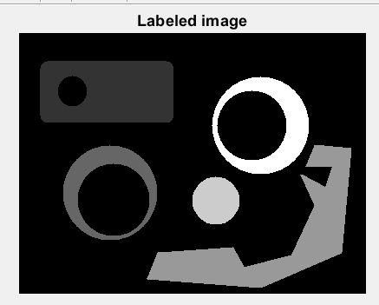

Question 5 What do the different shades of gray represent when the image is displayed?
Ada yang gela, sedikit terang, lebih terang sedikit lalu putih

Question 6 What other display options can you choose to make it easier to tell the different labeled regions apart?
Dengan menambahkan kode ini
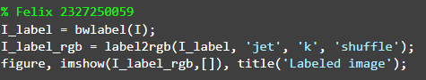
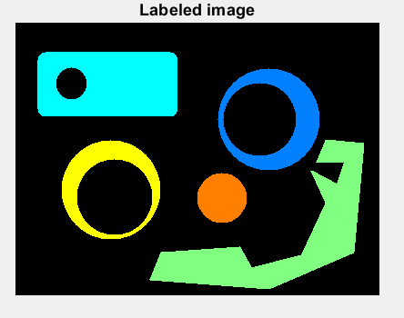

Thinning
Thinning is one of the many operations that can be achieved through the use of the bwmorph function (see Table 13.1 for a complete list).

- Use bwmorph to thin the original image with five iterations.
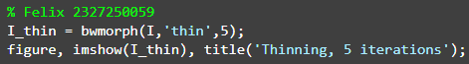
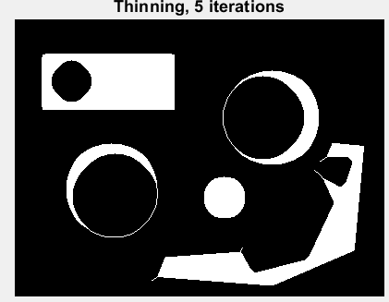

Question 7 What happens if we specify 10, 15, or Inf (infinitely many) iterations instead?
Semakin tipis detail dengan intensitas yang rendah gambar sampai hanya menjadi garis saja

Thickening
- Thicken the original image with five iterations.
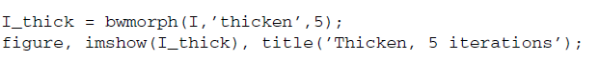
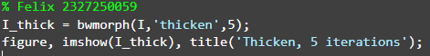
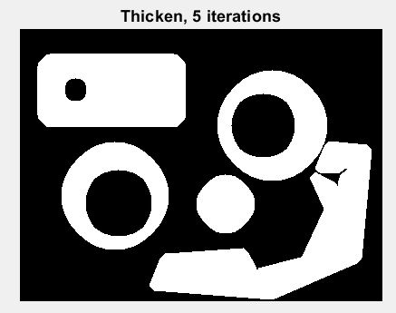

Question 8 What happens when we specify a higher number of iterations?
Kebalikan dari thin yaitu, semakin tebal atau besar yang memiliki intensitas tinggi.
Question 9 How does MATLAB know when to stop thickening an object? (Hint: Check to see what happens if we use Inf (infinitely many) iterations?
Jika kita menggunakan iterasi Inf, MATLAB akan terus menebalkan objek hingga tidak ada lagi piksel latar belakang yang bisa ditambahkan ke objek. Proses berhenti secara otomatis saat hasilnya tidak berubah lagi.

Skeletonization
- Close any open figures.
- Generate the skeleton using the bwmorph function.
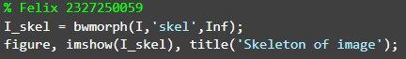
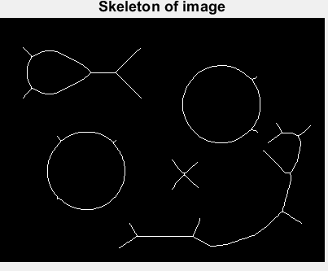

Question 10 How does skeletonization compare with thinning? Explain.
Skeletonisasi adalah proses menghasilkan kerangka dari suatu objek biner dengan ketebalan satu piksel yang mewakili bentuk aslinya. Sementara penipisan adalah proses mengurangi ketebalan objek secara iteratif dari tepi tanpa menghilangkan bentuk keseluruhan. Skeleton lebih fokus pada representasi struktur pusat, sedangkan thinning hanya menipiskan tanpa menjamin ketebalan satu piksel di semua bagian.

